***Wasting time correcting exams project***

***Team Member :***

1)Hadeer Youssif. Section(8) 2)Noran Hassan.Section(8)

3) Haidy Atef.Section(8) 4) Nourhan Hanna.Section(8)

***Project Manager : Hadeer Youssif***

***Project Sponsor : DR/Tarek Gammal***

***Wasting time correcting exams***

* ***Executive Summary*** :

*The problem of correcting exams takes a lot of time and effort, and there are also Mistakes in correction, and this affects many other things.*

*The solution is to implement an electronic correction system based on a program that corrects exams only.*

*To reduce all these mistakes and reduce a lot of time, the project will be implemented at the university in the Faculty of Computing and Information in the laboratory building.*

* ***Deliverables*** :

1. ***Required Information :***

*We collect data that will explain the examination system ,how it will work and how student will be tested for it.*

1. ***Design :***

*We follow the college system to know what the examination system is and through which we can design the program through which students are tested.*

1. ***development/coding :***

*We design the backend, which should contain:*

*1-server, which is the physical disk on which website data is stored*

*2-data base, a method for storing location data through which it is possible to query databases to fetch information and return it upon request.*

*-Designing the frontend.*

*After designing the backend and frontend, we test them to make sure that they work efficiently.*

1. ***Integration :***

*We combine the previous steps and test them to ensure that they work in the way that suits the system we want to apply.*

* ***Project Resources*** *:*

1. *Good internet connection*
2. *Server*
3. *Trainers who train students on the online examination system*

* ***Risk and Issue Management Plan*** :

*-Data loss.*

*-A problem occurs in the Internet.*

*-System hack.*

*-Data entry mistake.*

* ***Communication Management Plan*** :

*Meeting every week at 7 pm.*

* ***Project scope statement*** :
* ***Objectives*** *: Objectives are to apply the electronic correction system to reduce the time spent on correction and reduce the stress of students waiting for results.*
* ***Assumptions*** :

*It is expected that this system will succeed and will be applied to most or all colleges because it is characterized by speed and credibility, unlike manual correction, and also makes it easier for doctors to perform the cumbersome task of correction, which takes a lot of time and effort.*

* ***Project exclusions*** :

*This system will be applied in the Faculty of Computing and Information and not in the rest of the faculties. The students to whom this system is applied are the students who are tested in the laboratory building only.*

* ***Constrains*** :

*We will need about 4 months of time to finish the project and be integrated and ready for application*.

* ***Milestones*** :

*The project will be implemented from the beginning of October until the first of January, and we will train on it for a month in the beginning, an important discussion will take place in first of October between the members of the project . This is considered the most important event in the project .In the end of October, an examination is conducted on what has been done , and a meeting is held to review everything, and this meeting will be in the college in the morning. The project has many important events, such as allocating a day for important members of the project to gather, such as the dean of the college, doctors, teaching assistants, in first of December and examining the devices completely. we will collect the data and we train students to make sure that everything is correct،and the design of this system will follow the college system*

*We will design a back-end, which contains a server and a database, and we will collect all these steps and make sure that the work done , for example: trial exams to make sure that everything will be done with high accuracy, in January everything is ready.*

* ***Budget*** :

*We need instructors to train students how to handle the new test system. Each instructor has a specific cost within the 120,000 budget for instructors.*

* ***WBS :***

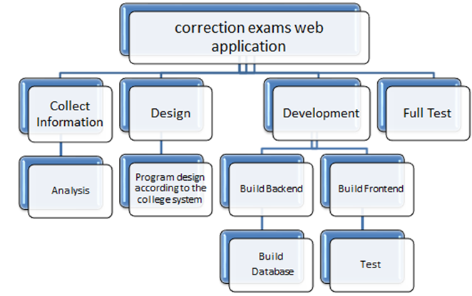

***Responsibility Matrix :***

|  |  |  |  |  |
| --- | --- | --- | --- | --- |
| *Task* | *Hadeer* | *Nourhan* | *Noran* | *Haidy* |
| *Collect information* | *R* | *S* | *S* | *S* |
| *Analysis* | *R* | *S* | *S* | *R* |
|  |  |  |  |  |
| *Build Backend* | *R* | *S* | *S* | *R* |
| *Build Database* | *S* | *R* | *R* |  |
| *Test Backend* |  |  | *R* | *S* |
| *Build Frontend* | *S* | *S* | *S* |  |
| *Test Frontend* |  |  |  | *S* |
| *Integration* | *R* | *S* | *S* |  |
| *Full Test* | *S* | *R* | *S* | *R* |

***R = Responsible S = Supports/Assists***

* ***Network Information :***

|  |  |  |  |
| --- | --- | --- | --- |
| Activity | Description | Preceding Activity | Activity Time/Weeks |
| A | Collect Information | None | 1 |
| B | Analysis | A | 1 |
| C | Build Backend | B | 2 |
| D | Build Database | C | 1 |
| E | Test Backend | C | 2 |
| F | Build Frontend | D | 2 |
| G | Test Frontend | E | 1 |
| H | Integration | F,G | 3 |
| I | Full Test | H | 2 |
|  |  |  |  |

***Network:***

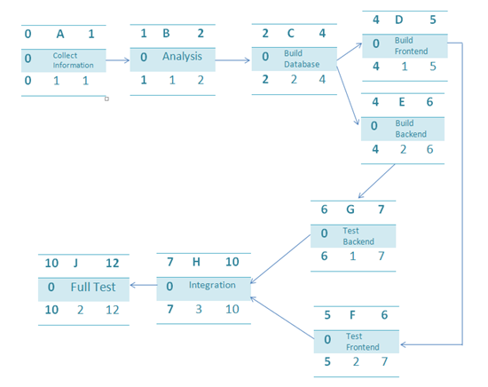

* **Gantt Chart :**

|  |  |  |  |  |  |  |  |  |  |  |  |  |  |  |  |  |  |  |  |
| --- | --- | --- | --- | --- | --- | --- | --- | --- | --- | --- | --- | --- | --- | --- | --- | --- | --- | --- | --- |
| ID | RES | DUR | ES | LF | SL | 0 | 1 | 2 | 3 | 4 | 5 | 6 | 7 | 8 | 9 | 10 | 11 | 12 |  |
| A | 2P | 1 | 0 | 1 | 0 | 2 |  |  |  |  |  |  |  |  |  |  |  |  |  |
| B | 2P | 1 | 1 | 2 | 0 |  | 2 |  |  |  |  |  |  |  |  |  |  |  |  |
| C | 1P | 2 | 2 | 4 | 0 |  |  | 1 | 1 |  |  |  |  |  |  |  |  |  |  |
| D | 1P | 1 | 4 | 6 | 0 |  |  |  |  | 1 |  |  |  |  |  |  |  |  |  |
| E | 2P | 2 | 4 | 6 | 0 |  |  |  |  | 2 | 2 |  |  |  |  |  |  |  |  |
| F | 1P | 2 | 5 | 7 | 0 |  |  |  |  |  | 1 | 1 |  |  |  |  |  |  |  |
| G | 2P | 1 | 6 | 7 | 0 |  |  |  |  |  |  | 2 |  |  |  |  |  |  |  |
| H | 2P | 3 | 7 | 10 | 0 |  |  |  |  |  |  |  | 2 | 2 | 2 |  |  |  |  |
| I | 1P | 2 | 10 | 12 | 0 |  |  |  |  |  |  |  |  |  |  | 1 | 1 |  |  |
| Total resource load |  |  |  |  |  | 2 | 2 | 1 | 1 | 3 | 3 | 2 | 2 | 2 | 2 | 1 | 1 |  |  |
| Available resource |  |  |  |  |  | 3 | 3 | 3 | 3 | 3 | 3 | 3 | 3 | 3 | 3 | 3 | 3 | 3 |  |

* ***Budget Baseline:***

|  |  |  |  |  |  |  |  |  |  |  |  |  |  |  |  |  |
| --- | --- | --- | --- | --- | --- | --- | --- | --- | --- | --- | --- | --- | --- | --- | --- | --- |
| ID | DUR | TASK | Budget | 0 | 1 | 2 | 3 | 4 | 5 | 6 | 7 | 8 | 9 | 10 | 11 | 12 |
| A | 1 | Collect information | 3 | 3 |  |  |  |  |  |  |  |  |  |  |  |  |
| B | 1 | Analysis | 2 |  | 2 |  |  |  |  |  |  |  |  |  |  |  |
| C | 2 | Build Backend | 5 |  |  | 2 | 3 |  |  |  |  |  |  |  |  |  |
| D | 1 | Build Database | 3 |  |  |  |  | 3 |  |  |  |  |  |  |  |  |
| E | 2 | Test Backend | 3 |  |  |  |  | 2 | 1 |  |  |  |  |  |  |  |
| F | 2 | Build Frontend | 2 |  |  |  |  |  | 2 |  |  |  |  |  |  |  |
| G | 1 | Test Frontend | 2 |  |  |  |  |  |  | 2 |  |  |  |  |  |  |
| H | 3 | Integration | 4 |  |  |  |  |  |  |  | 2 | 1 | 1 |  |  |  |
| I | 2 | Full Test | 7 |  |  |  |  |  |  |  |  |  |  | 4 | 3 |  |
| Week total |  |  |  | 3 | 2 | 2 | 3 | 5 | 3 | 2 | 2 | 1 | 1 | 4 | 3 |  |
| Cumulative |  |  |  | 3 | 5 | 7 | 10 | 15 | 18 | 20 | 22 | 23 | 24 | 28 | 31 |  |

* ***Cumulative Baseline Budget:***

|  |  |  |  |  |  |  |  |  |  |  |  |
| --- | --- | --- | --- | --- | --- | --- | --- | --- | --- | --- | --- |
|  |  |  |  |  |  |  |  |  |  |  |  |
| 35 |  |  |  |  |  |  |  |  |  |  |  |
| 30 |  |  |  |  |  |  |  |  |  |  |  |
| 25 |  |  |  |  |  |  |  |  |  |  |  |
| 20 |  |  |  |  |  |  |  |  |  |  |  |
| 15 |  |  |  |  |  |  |  |  |  |  |  |
| 10 |  |  |  |  |  |  |  |  |  |  |  |
| 5 |  |  |  |  |  |  |  |  |  |  |  |

0 1 2 3 4 5 6 7 8 9 10 11 12

* ***Risk and Issue Management Plan :***

1. *Data Loss: In order to solve the data loss problem ,all the data on the system should be backed up , because if we lose it , we know how to get it back again.*

*2) It is possible that there may be a problem with the computers that students are examining on. All devices must be checked before the exam begins.*

*3) The examination system can be hacked. It is possible that the exams are erased or changed. It is necessary to secure the system in good way so that this problem does not occur.*

*4) It is possible that mistake may occur when entering the examination data and its answers. Good observation must be taken during data entry to avoid problems with the student’s final grade.*